From: https://www.carbonbrief.org/analysis-why-scientists-think-100-of-global-warming-is-due-to-humans
Date: 20171213
By: Zeke Hausfather
[Analysis: Why scientists think 100% of global warming is due to humans]
[Note: Reading this from the below is very informative, but -FNC]
The extent of the human contribution to modern global warming is a hotly debated topic in political circles, particularly in the US.
During a recent congressional hearing, Rick Perry, the US energy secretary, remarked that “to stand up and say that 100% of global warming is because of human activity, I think on its face, is just indefensible”.
However, the science on the human contribution to modern warming is quite clear. Humans emissions and activities have caused around 100% of the warming observed since 1950, according to the Intergovernmental Panel on Climate Change’s (IPCC) fifth assessment report.
Here Carbon Brief examines how each of the major factors affecting the Earth’s climate would influence temperatures in isolation – and how their combined effects almost perfectly predict long-term changes in the global temperature.
Carbon Brief’s analysis finds that:
- Since 1850, almost all the long-term warming can be explained by greenhouse gas emissions and other human activities.
- If greenhouse gas emissions alone were warming the planet, we would expect to see about a third more warming than has actually occurred. They are offset by cooling from human-produced atmospheric aerosols.
- Aerosols are projected to decline significantly by 2100, bringing total warming from all factors closer to warming from greenhouse gases alone.
- Natural variability in the Earth’s climate is unlikely to play a major role in long-term warming.
Animation by Rosamund Pearce for Carbon Brief. Images via Alamy Stock Photo.

How much warming is caused by humans?
In its 2013 fifth assessment report, the IPCC stated in its summary for policymakers that it is “extremely likely that more than half of the observed increase in global average surface temperature” from 1951 to 2010 was caused by human activity. By “extremely likely”, it meant that there was between a 95% and 100% probability that more than half of modern warming was due to humans.
This somewhat convoluted statement has been often misinterpreted as implying that the human responsibility for modern warming lies somewhere between 50% and 100%. In fact, as NASA’s Dr Gavin Schmidt has pointed out, the IPCC’s implied best guess was that humans were responsible for around 110% of observed warming (ranging from 72% to 146%), with natural factors in isolation leading to a slight cooling over the past 50 years.
Similarly, the recent US fourth national climate assessment found that between 93% to 123% of observed 1951-2010 warming was due to human activities.
These conclusions have led to some confusion as to how more than 100% of observed warming could be attributable to human activity. A human contribution of greater than 100% is possible because natural climate change associated with volcanoes and solar activity would most likely have resulted in a slight cooling over the past 50 years, offsetting some of the warming associated with human activities.

‘Forcings’ that change the climate
Scientists measure the various factors that affect the amount of energy that reaches and remains in the Earth’s climate. They are known as “radiative forcings”.
These forcings include greenhouse gases, which trap outgoing heat, aerosols – both from human activities and volcanic eruptions – that reflect incoming sunlight and influence cloud formation, changes in solar output, changes in the reflectivity of the Earth’s surface associated with land use, and many other factors.
To assess the role of each different forcing in observed temperature changes, Carbon Brief adapted a simple statistical climate model developed by Dr Karsten Haustein and his colleagues at the University of Oxford and University of Leeds. This model finds the relationship between both human and natural climate forcings and temperature that best matches observed temperatures, both globally and over land areas only.
The figure below shows the estimated role of each different climate forcing in changing global surface temperatures since records began in 1850 – including greenhouse gases (red line), aerosols (dark blue), land use (light blue), ozone (pink), solar (yellow) and volcanoes (orange).
The black dots show observed temperatures from the Berkeley Earth surface temperature project, while the grey line shows the estimated warming from the combination of all the different types of forcings
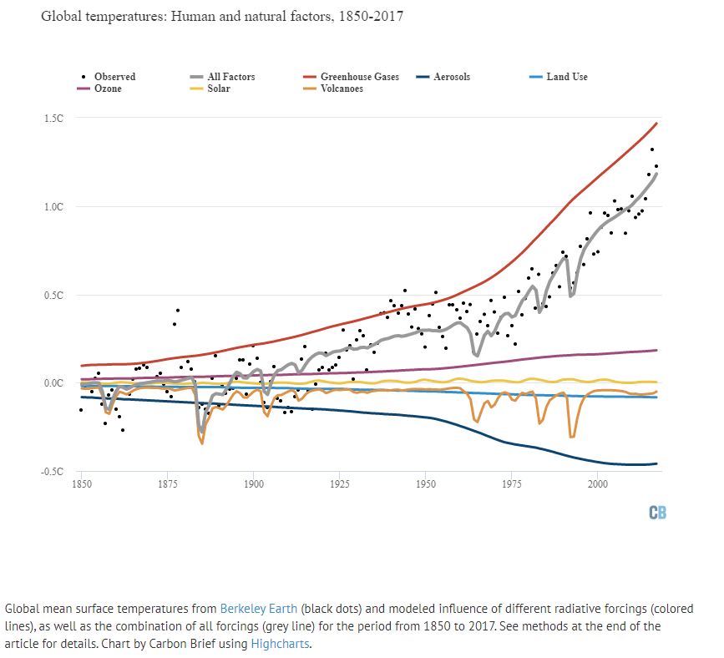
Global mean surface temperatures from Berkeley Earth (black dots) and modeled influence of different radiative forcings (colored lines), as well as the combination of all forcings (grey line) for the period from 1850 to 2017. See methods at the end of the article for details. Chart by Carbon Brief using Highcharts. [Note: Online, the chart above is much enhanced, because it is interactive. -FNC]
The combination of all radiative forcings generally matches longer-term changes in observed temperatures quite well. There is some year-to-year variability, primarily from El Niño events, that is not driven by changes in forcings. There are also periods from 1900-1920 and 1930-1950 where some larger disagreements are evident between projected and observed warming, both in this simple model and in more complex climate models.
The chart highlights that, of all the radiative forcings analysed, only increases in greenhouse gas emissions produce the magnitude of warming experienced over the past 150 years.
If greenhouse gas emissions alone were warming the planet, we would expect to see about a third more warming than has actually occurred.
So, what roles do all the other factors play?
Related articles
- Q&A: How do climate models work?
- Interactive: The impacts of climate change at 1.5C, 2C and beyond
- Explainer: How scientists estimate ‘climate sensitivity’
- Mapped: How every part of the world has warmed – and could continue to warm
The extra warming from greenhouse gases is being offset by sulphur dioxide and other products of fossil fuel combustion that form atmospheric aerosols. Aerosols in the atmosphere both reflect incoming solar radiation back into space and increase the formation of high, reflective clouds, cooling the Earth.
Ozone is a short-lived greenhouse gas that traps outgoing heat and warms the Earth. Ozone is not emitted directly, but is formed when methane, carbon monoxide, nitrogen oxides and volatile organic compounds break down in the atmosphere. Increases in ozone are directly attributable to human emissions of these gases.
In the upper atmosphere, reductions in ozone associated with chlorofluorocarbons (CFCs) and other halocarbons depleting the ozone layer have had a modest cooling effect. The net effects of combined lower and upper atmospheric ozone changes have modestly warmed the Earth by a few tenths of a degree.
Changes in the way land is used alter the reflectivity of the Earth’s surface. For example, replacing a forest with a field will generally increase the amount of sunlight reflected back into space, particularly in snowy regions. The net climate effect of land-use changes since 1850 is a modest cooling.
Volcanoes have a short-term cooling effect on the climate due to their injection of sulphate aerosols high into the stratosphere, where they can remain aloft for a few years, reflecting incoming sunlight back into space. However, once the sulphates drift back down to the surface, the cooling effect of volcanoes goes away. The orange line shows the estimated impact of volcanoes on the climate, with large downward spikes in temperatures of up to 0.4C associated with major eruptions.

January 3, 2009 – Santiaguito eruption, Guatemala. Credit: Stocktrek Images, Inc. / Alamy Stock Photo.
Finally, solar activity is measured by satellites over the past few decades and estimated based on sunspot counts in the more distant past. The amount of energy reaching the Earth from the sun fluctuates modestly on a cycle of around 11 years. There has been a slight increase in overall solar activity since the 1850s, but the amount of additional solar energy reaching the Earth is small compared to other radiative forcings examined.
Over the past 50 years, solar energy reaching the Earth has actually declined slightly, while temperatures have increased dramatically.

Human forcings match observed warming
The accuracy of this model depends on the accuracy of the radiative forcing estimates. Some types of radiative forcing like that from atmospheric CO2 concentrations can be directly measured and have relatively small uncertainties. Others, such as aerosols, are subject to much greater uncertainties due to the difficulty of accurately measuring their effects on cloud formation.
These are accounted for in the figure below, which shows combined natural forcings (blue line) and human forcings (red line) and the uncertainties that the statistical model associates with each. These shaded areas are based on 200 different estimates of radiative forcings, incorporating research attempting to estimate a range of values for each. Uncertainties in human factors increase after 1960, driven largely by increases in aerosol emissions after that point.
Global mean surface temperatures from Berkeley Earth (black dots) and modelled influence of all combined natural (blue line) and human (red line) radiative forcings with their respective uncertainties (shaded areas) for the period from 1850 to 2017. The combination of all natural and human forcings (grey line) is also shown. See methods at the end of the article for details. Chart by Carbon Brief using Highcharts. [Note: Online, the chart above is much enhanced, because it is interactive. -FNC]
Overall, warming associated with all human forcings agrees quite well with observed warming, showing that about 104% of the total since the start of the “modern” period in 1950 comes from human activities (and 103% since 1850), which is similar to the value reported by the IPCC. Combined natural forcings show a modest cooling, primarily driven by volcanic eruptions.
The simple statistical model used for this analysis by Carbon Brief differs from much more complex climate models generally used by scientists to assess the human fingerprint on warming. Climate models do not simply “fit” forcings to observed temperatures. Climate models also include variations in temperature over space and time, and can account for different efficacies of radiative forcings in different regions of the Earth.
However, when analysing the impact of different forcings on global temperatures, complex climate models generally find results similar to simple statistical models. The figure below, from the IPCC’s Fifth Assessment Report, shows the influence of different factors on temperature for the period from 1950 to 2010. Observed temperatures are shown in black, while the sum of human forcings is shown in orange.
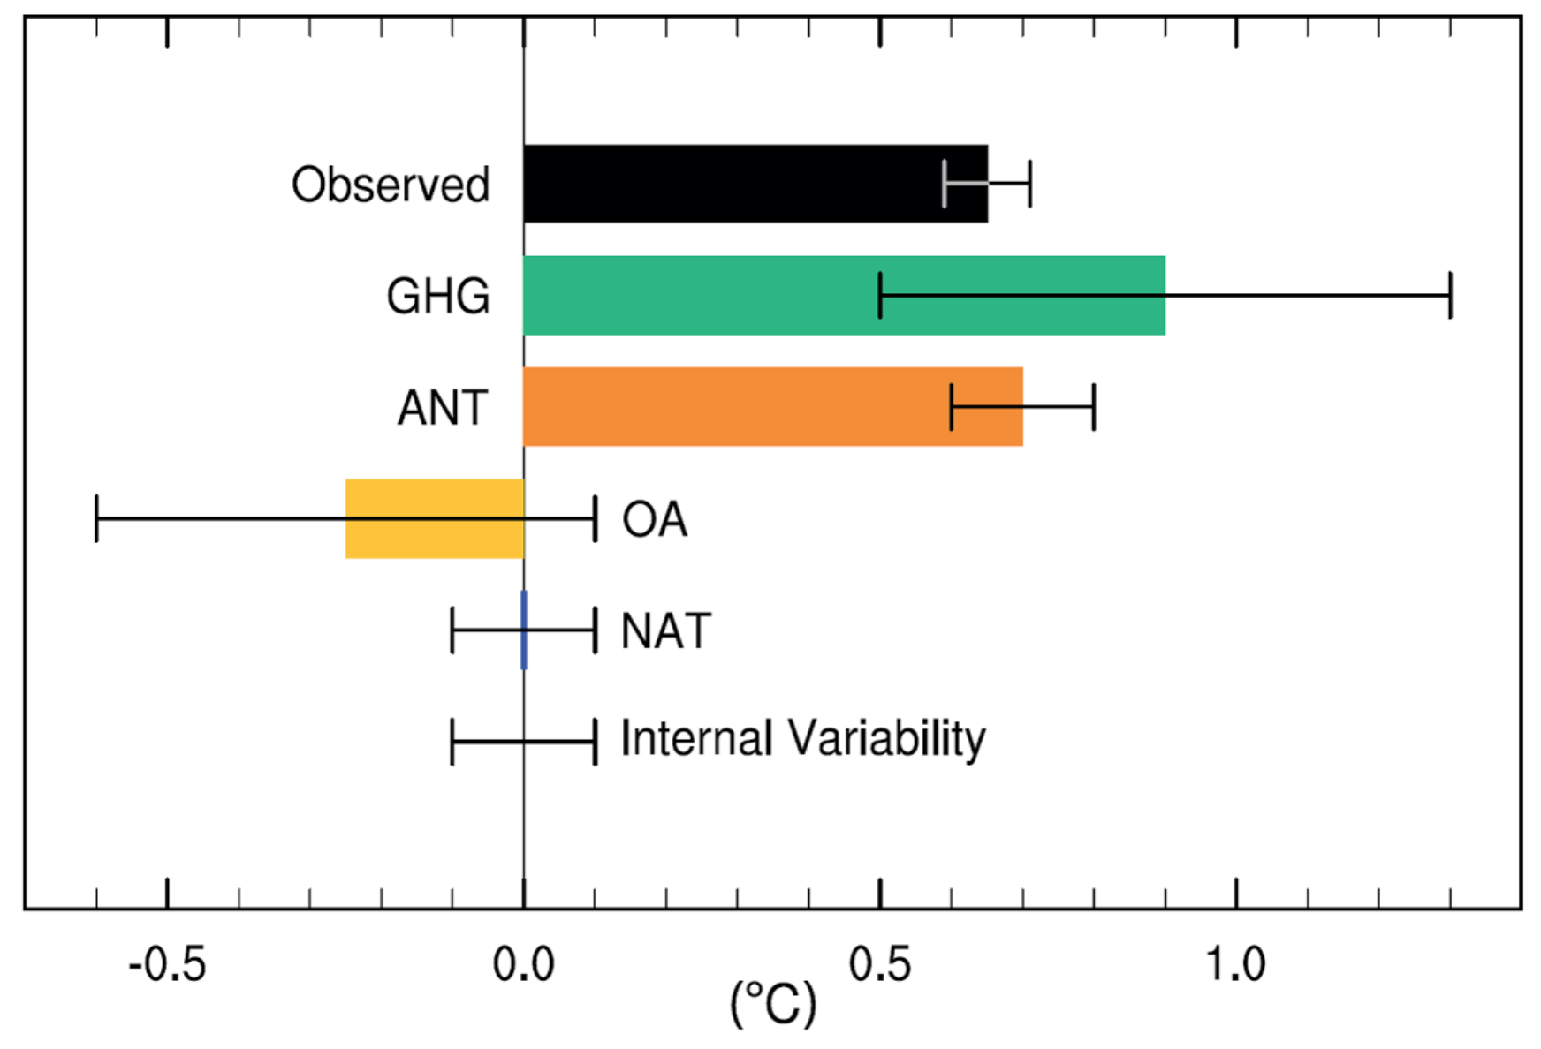
Figure TS10 from the IPCC Fifth Assessment Report. Observed temperatures are from HadCRUT4. GHG is all well-mixed greenhouse gases, ANT is total human forcings, OA is human forcings apart from GHG (mostly aerosols), NAT is natural forcings (solar and volcanoes), and Internal Variability is an estimate of the potential impact of multidecadal ocean cycles and similar factors. Error bars show one-sigma uncertainties for each. Source: IPCC.
This suggests that human forcings alone would have resulted in approximately 110% of observed warming. The IPCC also included the estimated magnitude of internal variability over that period in the models, which they suggest is relatively small and comparable to that of natural forcings.
As Prof Gabi Hegerl at the University of Edinburgh tells Carbon Brief: “The IPCC report has an estimate that basically says the best guess is no contribution [from natural variability] with not that much uncertainty.”

Land areas are warming faster
Land temperatures have warmed considerably faster than average global temperatures over the past century, with temperatures reaching around 1.7C above pre-industrial levels in recent years. The land temperature record also goes back further in time than the global temperature record, though the period prior to 1850 is subject to much greater uncertainties.
Both human and natural radiative forcings can be matched to land temperatures using the statistical model. The magnitude of human and natural forcings will differ a bit between land and global temperatures. For example, volcanic eruptions appear to have a larger influence on land, as land temperatures are likely to respond faster to rapid changes in forcings.
The figure below shows the relative contribution of each different radiative forcing to land temperatures since 1750.
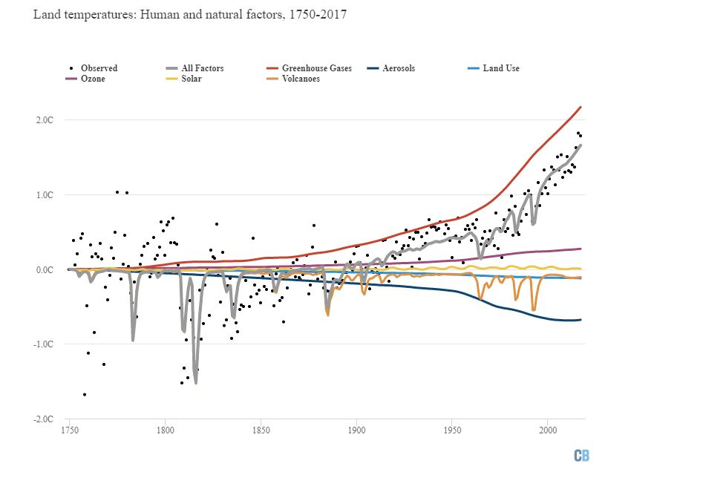
Land mean surface temperatures from Berkeley Earth (black dots) and modeled influence of different radiative forcings (colored lines), as well as the combination of all forcings (grey line) for the period from 1750 to 2017. Chart by Carbon Brief using Highcharts. [Note: Online, the chart above is much enhanced, because it is interactive. -FNC]
The combination of all forcings generally matches observed temperatures quite well, with short-term variability around the grey line primarily driven by El Niño and La Niña events. There is a wider variation in temperatures prior to 1850, reflecting the much larger uncertainties in the observational records that far back.
There is still a period around 1930 and 1940 where observations exceed what the model predicts, though the differences are less pronounced than in global temperatures and the 1900-1920 divergence is mostly absent in land records.
Volcanic eruptions in the late 1700s and early 1800s stand out sharply in the land record. The eruption of Mount Tambora in Indonesia in 1815 may have cooled land temperatures by a massive 1.5C, though records at the time were limited to parts of the Northern Hemisphere and it is, therefore, hard to draw a firm conclusion about global impacts. In general, volcanoes appear to cool land temperatures by nearly twice as much as global temperatures.

What may happen in the future?
Carbon Brief used the same model to project future temperature changes associated with each forcing factor. The figure below shows observations up to 2017, along with future post-2017 radiative forcings from RCP6.0, a medium-to-high future warming scenario.
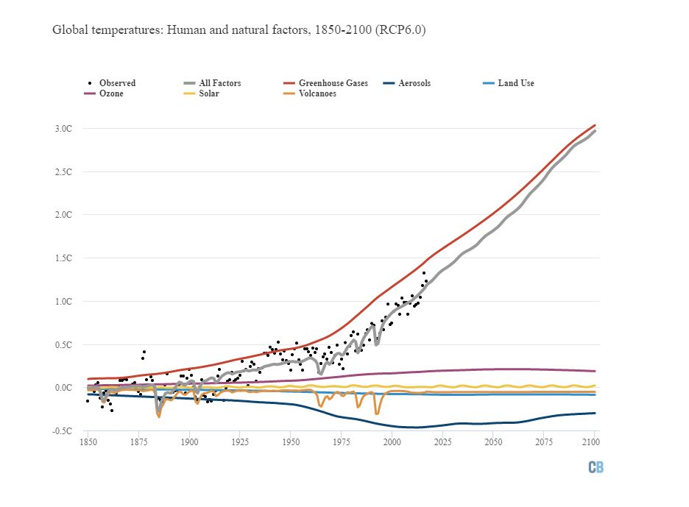
Global mean surface temperatures from Berkeley Earth (black dots) and modeled influence of different radiative forcings (colored lines) for the period from 1850 to 2100. Forcings post-2017 taken from RCP6.0. Chart by Carbon Brief using Highcharts. [Note: Online, the chart above is much enhanced, because it is interactive. -FNC]
When provided with the radiative forcings for the RCP6.0 scenario, the simple statistical model shows warming of around 3C by 2100, nearly identical to the average warming that climate models find.
- Future radiative forcing from CO2 is expected [assumed by RCP6.0] to continue to increase if [CO2] emissions rise.
- Aerosols, on the other hand, are projected [assumed by RCP6.0] to peak at today’s levels and decline significantly by 2100, driven in large part by concerns about air quality. This reduction in aerosols will enhance overall warming, bringing total warming from all radiative forcing closer to warming from greenhouse gases alone.
- The RCP scenarios [all of them?] assume no specific future volcanic eruptions, as the timing of these is unknowable, while [for all of them?]
- solar output continues its 11-year cycle.
- This [assumption / guessing] approach can also be applied to land temperatures, as shown in the figure below. Here, land temperatures are shown between 1750 and 2100, with post-2017 forcings also from RCP6.0.
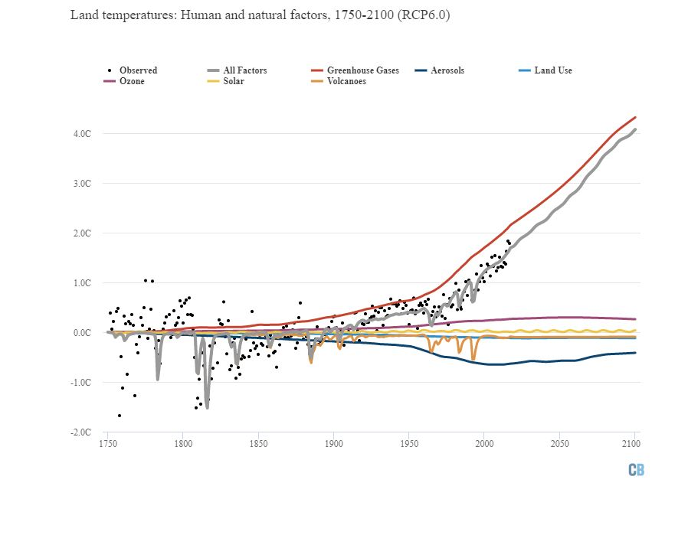
Land mean surface temperatures from Berkeley Earth (black dots) and modeled influence of different radiative forcings (colored lines) for the period from 1750 to 2100. Forcings post-2017 taken from RCP6.0. Chart by Carbon Brief using Highcharts. [Note: Online, the chart above is much enhanced, because it is interactive. -FNC]
The land is expected [assumed] to warm about 30% faster than the globe as a whole, as the rate of warming over the oceans is buffered by ocean heat uptake. This is seen in the model results, where land warms by around 4C by 2100 compared to 3C globally in the RCP6.0 scenario.
There is a wide range of future warming possible from different RCP scenarios and different values for the sensitivity of the climate system, but all show a similar pattern of declining future aerosol emissions and a larger role for greenhouse gas forcing in future temperatures.

The role of natural variability
[Variability occurs 26 times in this doc. Natural variability occurs 11 times in this doc. While human occurs 46 times (mostly as an adjective), human variability occurs 0 times. ]
While natural forcings from solar and volcanoes do not seem to play much of a role in long-term warming, there is also
- natural variability associated with ocean cycles and variations in ocean heat uptake.
As the vast majority of energy trapped by greenhouse gases is absorbed by the oceans rather than the atmosphere, changes in the rate of ocean heat uptake can potentially have large impacts on the surface temperature.
Some researchers have argued that multidecadal cycles, such as the Atlantic Multidecadal Oscillation (AMO) and Pacific Decadal Oscillation (PDO), can play a role in warming at a decadal scale.
While human factors explain all the long-term [long-term must mean 'at a centuries scale'.] warming, there are some specific periods that appear to have warmed or cooled faster than can be explained based on our best estimates of radiative forcing. For example, the modest mismatch between the radiative forcing-based estimate and observations during the mid-1900s might be evidence of a role for natural variability during that period.
A number of researchers have examined the potential for natural variability to impact long-term warming trends. They have found that it generally plays a limited role. For example, Dr Markus Huber and Dr Reto Knutti at the Institute for Atmospheric and Climate Science (IAC) in Zurich found a maximum possible contribution of natural variability of around 26% (+/- 12%) over the past 100 years and 18% (+/- 9%) over the past 50 years.
Knutti tells Carbon Brief:
“We can never completely rule out that natural variability is larger than we currently think. But that is a weak argument: you can, of course, never rule out the unknown unknown. The question is whether there is strong, or even any evidence for it. And the answer is no, in my view.
Models get the short-term temperature variability approximately right. In many cases, they even have too much. And for the long term, we can’t be sure because the observations are limited. But the forced response pretty much explains the observations, so there is no evidence from the 20th century that we are missing something…
Even if models were found to underestimate internal variability by a factor of three, it is extremely unlikely [less than 5% chance] that internal variability could produce a trend as large as observed.”
Similarly, Dr Martin Stolpe and colleagues, also at IAC, recently analysed the role of multidecadal natural variability in both the Atlantic and Pacific oceans. They found that “less than 10% of the observed global warming during the second half of the 20th century is caused by internal variability in these two ocean basins, reinforcing the attribution of most of the observed warming to anthropogenic forcings”.
Internal variability [Natural variability ?] is likely to have a much larger role in regional temperatures. For example, in producing unusually warm periods in the Arctic and the US in the 1930s. However, its role in influencing long-term changes in global surface temperatures appears to be limited.

Conclusion
While there are natural factors that affect the Earth’s climate, the combined influence of volcanoes and changes in solar activity would have resulted in cooling rather than warming over the past 50 years.
The global warming witnessed over the past 150 years matches nearly perfectly what is expected from greenhouse gas emissions and other human activity, both in the simple model examined here and in more complex climate models. The best estimate of the human contribution to modern warming is around 100%.
Some uncertainty remains due to the role of natural variability, but researchers suggest that ocean fluctuations and similar factors are unlikely to be the cause of more than a small fraction of modern global warming.
Methodology
The simple statistical model used in this article is adapted from the Global Warming Index published by Haustein et al (2017). In turn, it is based on the Otto et al (2015) model.
The model estimates contributions to observed climate change and removes the impact of natural year-to-year fluctuations by a multiple linear regression of observed temperatures and estimated responses to total human-induced and total natural drivers of climate change. The forcing responses are provided by the standard simple climate model given in Chapter 8 of IPCC (2013), but the size of these responses is estimated by the fit to the observations. The forcings are based on IPCC (2013) values and were updated to 2017 using data from NOAA and ECLIPSE. 200 variations of these forcings were provided by Dr. Piers Forster of the University of Leeds, reflecting the uncertainty in forcing estimates. An Excel spreadsheet containing their model is also provided.
The model was adapted by calculating forcing responses for each of the different major climate forcings rather than simply total human and natural forcings, using the Berkeley Earth record for observations. The decay time of thermal response used in converting forcings to forcing responses was adjusted to be one year rather than four years for volcanic forcings to better reflect the fast response time present in observations. The effects of El Niño and La Niña (ENSO) events was removed from the observations using an approach adapted from Foster and Rahmstorf (2011) and the Kaplan El Niño 3.4 index when calculating the volcanic temperature response, as the overlap between volcanoes and ENSO otherwise complicates empirical estimates.
The temperature response for each individual forcing was calculated by scaling their forcing responses by the total human or natural coefficients from the regression model. The regression model was also run separately for land temperatures. Temperature responses for each forcing between 2018 and 2100 were estimated using forcing data from RCP6.0, normalised to match the magnitude of observed forcings at the end of 2017.
Uncertainties in total human and total natural temperature response was estimated using a Monte Carlo analysis of 200 different forcing series, as well as the uncertainties in the estimated regression coefficients. The Python code used to run the model is archived with GitHub and available for download.
Observational data from 2017 shown in the figures is based on the average of the first 10 months of the year and is likely to be quite similar to the ultimate annual value.
Sharelines from this story

Why scientists think 100% of global warming is due to humans
Comments
Close Comments
Comments for this thread are now closed
- 18 Comments
- Carbon Brief
- Frederick N. Chase

- Recommend
- TweetShare
- Sort by Newest

  - −


AlbertoZaragozaComendador • 2 years ago
This article ignores the elephant in the room: natural forcings other than solar radiation and volcano aerosols. This is typical: climate scientists often implicitly state these forcings don't exist by partitioning temperature factors into man-made forcings, natural forcings (including only the sun and volcanoes), and "internal variability" (implying said variability comes from a redistribution of heat and not from a forcing).
Well, changes in clouds and water vapor may be "internal" in the sense that they originate from the climate system itself, but they affect the Earth's energy balance, so they definitely count as radiative forcings! For instance: https://www.ncbi.nlm.nih.go...
"However, due to the heterogeneous distribution of TMLCs and the varying surface temperature and albedo, the radiative effect may vary from one region to another (Fig. 4). For constant TMLC properties and if the surface temperature and albedo are colder and lower, respectively, than what is shown by the dashed line in Fig. 4b, the radiative effect of the TMLCs would be more negative and vice versa. Over bright surfaces such as deserts (albedo ∼0.40), TMLCs have a warming effect while they have a cooling effect over dark surfaces such as oceans (albedo ∼0.06)"
So you could have warming effect (i.e. positive forcing) from clouds simply due to a redistribution of thin, mid-level clouds from dark to bright surfaces. Notice that such a positive forcing does NOT imply positive cloud feedback, for the change in the cloud distribution itself, which is what's causing the warming (in the hypothesis), may or may not have arisen from a temperature increase. It may as well have arisen from random wind patterns, or changes in any of the many kinds of aerosols that clouds condense around.
The forcing from water vapor is about 70w/m2 iirc, while that of clouds is about -50w/m2 for solar radiation and 30w/m2 for infrared, or a net of about -20w/m2. It's difficult to say what would be "natural" variation in this forcing, as CERES data only goes back to 2000. But our understanding of ocean heat uptake is arguably even more incomplete and recent (the Argo gloats only achieved global coverage in the 200s).
A case can be made that forcing from water vapor (and ozone) would be expected to remain constant over time, but why would clouds remain constant? Cloud height, distribution (over areas with more or less albedo and more or less IR emission), thickness, etc are always changing; just because we don't know exactly *how* they change doesn't mean they would've stayed constant in the absence of man-made influence! To be clear, surely the most reasonable assumption is that, in fact, this natural cloud forcing would in fact have remained stable in the absence of man - lacking evidence one way or another, a neutral assumption seems the best choice. Also, mathematically, it's implausible that clouds could account for a majority of the warming. Man-made forcing is now about 2.5w/m2 and it seems very unlikely that natural cloud forcing could have changed in a comparable manner (it would involve a shrinking of over 10% in the cloud's net radiative effect, e.g. from -22 to -19.5w/m2).
But that is something this article and a million other "explanatory" pieces fail to explain. They give the impression that clouds and other natural factors *cannot* have a century-scale effect on temperature, when in fact we just *don't know* if they've had such an effect.
The omission of the clouds is all the more ironic because you do mention the rate of ocean heat uptake, which is only about 0.8w/m2. And that's only for the last decade (previously it was much smaller), while *changes* in that rate of uptake are much smaller still. Furthermore, it's easy to see how changes in cloud properties can change their radiative properties; a physical explanation for natural changes in the rate of ocean heat uptake is much harder to conceive. There is no justification for mentioning possible influence on surface temperature from changes in ocean heat uptake while ignoring much larger changes in cloud radiative forcing. The fact that you include ENSO in your explanation only adds irony - yes, ENSO cannot change temperatures over a century-scale period, but everybody already knows that.
A more convincing explanation of why it's unlikely that much of the warming we've seen is natural would use statistics and try to determine what is the "normal" long-run variability in the climate system, for what we care about is long-run warming, not just year-to-year or decade-to-decade changes. That is what Lovejoy did, I believe. (It may also be what the Huber and Paper did; I cannot tell as it's paywalled). But he only ruled out that ALL of the warming could be natural; ruling out, say, a 20% of warming caused by a 0.5w/m2 decline in the clouds' cooling effect is something researchers haven't done yet.
  - 2
  - •
  - Share ›


Tom Dayton AlbertoZaragozaComendador • 2 years ago
Alberto, you misunderstand the very definition of "forcing." Consequently your entire comment is wrong. Learn what "forcing" means. Learn what "feedback" means. Learn what "internal variability" means. Then read a textbook on global warming. David Archer's book, for example. Everything you mention actually is considered, in excruciating detail, by climate scientists.
    - 4
    - •
    - Share ›


mkaiser586 Tom Dayton • 2 years ago
No matter how much indisputable science and evidence is presented to these climate doubters, it will have no affect on their continual denial. Their minds are made up and will not change no matter how obvious it made to them. Such is the world we now live in where cold, hard facts are ignored and opinions and "alternative facts" dominate their bias beliefs.
      - 1
      - •
      - Share ›


stupidicus Tom Dayton • 2 years ago
They need to get their heads outta the clouds once and for all https://www.theguardian.com...
      - 1
      - •
      - Share ›


Cliff_Goudey AlbertoZaragozaComendador • 2 years ago
Your elephant has, to date, been impotent.
    - 1
    - •
    - Share ›


Aubrey Meyer • 2 years ago • edited
Editor Leo Hickman's justification that Carbon Brief published this article is,
"whatever was 'known' 20 years ago is irrelevant today."
Really - why is that?
http://www.gci.org.uk/carbo...
He goes on, "There is still plenty of ignorance-confusion-misinformation out there and it hasn't really been meaningfully acted upon, has it?"
OK, so what is, "acting-meaningfully on 'ignorance-confusion-misinformation" in a manner that is relevant to today?
20 years ago whatever that might have been, might have been worth it. Today it is just a more meaningless distraction with wider and wider error-bars & yet more ludicrous 'probability distributions': -
http://www.gci.org.uk/HMG's...
The editor may not have noticed, but acting meaningfully against all this sadly now equals litigation: - http://www.gci.org.uk/Judic... …
  - 1
  - •
  - Share ›


This comment was deleted.

mkaiser586 Guest • 2 years ago
I guess you must be smarter than the entire scientific community then huh? Bottom line is this: mankind is almost definitely responsible for the warming of the Earth's land areas by about 2 degrees from 1850 until now, and it will soon become 4 degrees by the end of the century. Are you ok with that, ok do you just not care cause you won't be around in the year 2100?

    - •
    - Share ›


Gary Guest • 2 years ago
No credible scientists actually believe this. They also know that we are not having an Ice Age nor is Earth getting cooler! Try reality for a while :-)
https://www.facebook.com/IF...
    - 1
    - •
    - Share ›


Billhook • 2 years ago • edited
Zeke - this is by far the best lay overview of the human fingerprint on global heating that I've seen in almost 40 years of tracking the issue. I'd urge CB to make strong efforts to get it republished elsewhere - e.g.: FT, Guardian, Climate Central, Climate Home, Le Monde, NY Times, The Economist, etc ?
One of the questions it poses is over the impacts of the current 'Fossil Sulphate Parasol', which is shown as giving (most of) 0.459C of cooling in 2017. If the hazardous and clearly sub-optimal form of Albedo Restoration (aka SRM) known as Stratospheric Sulphate Aerosols were deployed to give 0.9C or about twice this level of cooling, it would reportedly have very damaging effects on rainfall distribution threatening the crops of at least hundreds of millions of people. So what effects on rainfall distribution are already being suffered due to half that level of stratospheric sulphate aerosols ? If you find any cogent studies of this issue I hope you'll make time for a further article on them as declining food security - or rather the date of onset of serial global crop failures and their consequent ruinous geo-political destabilization - seems to me the proximate threat whose urgency far outweighs that of issues such as rising hurricane intensity and sea level rise.
A further question arises from the IPCC data used by Berkeley Earth in terms of its arbitrary assumption that the effects of seven of the eight 'Major Interactive Feedbacks' [MIFs] can be described as a linear warming factor known as the planet's 'Climate Sensitivity'. For clarity's sake I'd list those MIFs as: Ocean Heating & Acidification; Water Vapour Increase; Albedo Loss; Fertilized Peatbog Decay; Permafrost Melt; Soil Desiccation; Forest Decline; and Methyl Hydrates' Melt, of which all but the first are reportedly already accelerating their feedback effects, and all but the second are non-linear in their growth.
As you'll be well aware (unlike others) the IPCC includes only the near-linear Water Vapour Increase MIF in its quantified assessments, and has yet to provide even a track-record of the acceleration of the other seven MIFs, despite widespread published research of their ongoing acceleration. It has also failed to provide any substantial account of their two modes of interaction:
- first, they interact via chains of 'Direct Coupling Mechanisms' whereby the regional impacts of one causes the acceleration of a second that then accelerates a third, and so on. The widely cited example of this is of the Ocean Heating & Acidification MIF causing greater heat to be carried by the Gulf Stream into the Arctic Ocean, where it accelerates the loss of sea-ice and so Albedo Loss, which in turn allows more solar heat into the ocean warming the air-masses above it, which then move over the continents accelerating Permafrost Melt (the signature of this having been recorded up to 1500kms from the Russian coast) while also contributing to conditions generating '10,000-yr' wildfires driving the Forest Decline MIF;
- second, they interact via the ~35yr timelagged warming from each MIF reinforcing both its own acceleration and also that of all others - bar the CO2-driven Fertilized Peatbog Decay MIF, which accelerates both on its own CO2 output and on that of the other four carbon-emitting MIFs.
It is a shame that few scientists have chosen to face the daunting task of quantifying the potential future non-linear rate of growth of feedback emissions under their two modes of interactive acceleration, as it seems patently obvious that if not controlled they will inevitably fully offset even a total halt of anthro-GHG outputs. This would represent only a tiny fraction of their combined immense carbon stocks, and the most advanced (Albedo Loss) has already been shown (by Ramanathan, Pistone, et al, 2015) to have provided warming equal on average to 25% of anthro-CO2's warming during the satellite record since the 1970s.
The orthodox assumption that we have set a course for global 'temperature stabilization' is thus an illusion - halting the anthropogenic drivers of global heating at 2.0C or some other temperature will not control the interaction of the MIFs, which will inevitably continue to accelerate without the driver of anthro-GHGs. Given that CO2 resides in the atmosphere for at least a century, their control will require an intervention to provide rapid global cooling to decelerate them back to their C19 stability. Notably the Carbon Recovery mode of climate engineering shows no sign of being capable of achieving this by itself in less than a century, since several hundred billions of tonnes of carbon must be recovered from the atmosphere, followed by more coming back out of the oceans.
If these observations are essentially correct, then they give a fresh perspective on the real rationale for the R,D&D of a reliably benign form of the Albedo Restoration mode of climate engineering. It is nothing to do with "buying time to reduce anthro-GHG outputs" - its real justification is not only in restoring sufficient climate stability both to buttress global food security and to halt the decline of forest cover that will be crucial for Carbon Recovery, but also to decelerate all eight of the MIFs as rapidly as possible while we are still able to avoid their running beyond the possibility of control.
I've laid out these observation with one hope in view - that they may encourage you [the Author] to find the time to contact the best scientists you can reach and to put together articles as good as the one above that address the long ignored issue of the MIFs' ruinous potential, and the rationale for and requirements of the R,D&D of both the Carbon Recovery and Albedo Restoration modes of climate engineering. To be blunt, without the latters' combined deployment, our best efforts at rapidly ending fossil fuel dependence look to me far too little and fifty years too late.
With warm regard,
Lewis Cleverdon
  - 2
  - •
  - Share ›

Paul Barry Billhook • 2 years ago
Hi Lewis,
You make some interesting points there that I think are valid.
However I don't think your account of the assumptions used for climate sensitivity are quite right. They are not as arbitrary as you claim.
My understanding is that most of the feedbacks you refer to are more commonly described as Earth System feedbacks in the literature and they are examined in quite a bit of detail in various chapters of the IPCC's Working Group I report.
It does seem to me however that they did not receive enough attention in the AR5 synthesis report.
Part of the reason, I think, is that they are viewed as slow feedbacks occurring on timescales of centuries, so their impact on the warming of the 21st century is not expected to be very large.
Equilibrium Climate Sensitivity (ECS) estimates take into account many different “fast” feedbacks (as they are called) not just water-vapour. It is true that it does not include slow ES feedbacks.
RCP scenarios used for projections, however, do take into account some ES feedbacks – C cycle changes for example (see Chapter 6 of the IPCC AR5 WGI report).
There is a case to be made that there is a risk that these large feedbacks, though slower, may still have important effects on warming this century (as well as beyond that), which should not be ignored. The high level of uncertainty is seriously concerning. This is the fat-tail risk that people talk about.
I haven't come across the "MIF" term before. ["the eight 'Major Interactive Feedbacks' [MIFs]" ] Do you a reference for your analysis above? It sounds like it would make an interesting read.
    - 1
    - •
    - Share ›

Rthuba • 2 years ago • edited
Based on the 5 million, 1 million year warming and cooling cycles, 26k year Earth cycle around the sun and the Sunspot issues we are headed toward Global cooling that would take us back to the ice sheets of 12k years ago?
But man-made global warming is keeping it 'level'?
  - 1
  - •
  - Share ›


Al Rodger Rthuba • 2 years ago • edited
Rthuba,
The work of Bill Ruddiman may be of interest. His proposal is that early mankind added CO2 & CH4 to the atmosphere (although the 'how' remains an interesting question given the small human population back then; interesting but not fatal for the theory) and this prevented the cooling into the next ice age, along with preventing the resulting drops in CO2 & CH4 required to bring on ice ages. See for instance Ruddiman (2003)

    - •
    - Share ›

With Respect Rthuba • 2 years ago
Level?
Nope. Far overshot, and premature.
In another 14k years, pushing CO2 levels to 350 ppmv in a well-managed effort might have had a leveling effect. If geoengineering is your thing, and you think 14k years is enough time for people to organize it.
    - 1
1
    - •
    - Share ›

Rthuba With Respect • 2 years ago • edited
in the last 200 million years where are we currently in C02 levels?
sorry, I should say 300 million to get to levels this low... Unless you use charts that start in the 1400's, then it appears like a straight up chart.

      - •
      - Share ›

With Respect Rthuba • 2 years ago
Faint Young Sun Paradox.
If you stop wasting peoples' time with nonsense, people will stop using the Disqus Block User feature on you.
        - 2
        - •
        - Share ›

Rthuba With Respect • 2 years ago
so C02 isn't at one of its lowest points using a 200+ million year chart?

          - •
          - Share ›

With Respect • 2 years ago
Informative and thoughtful.
A phrase I never thought to use to refer to anything containing the words "Rick Perry".
  - 4
  - •
  - Share ›

